PROJECT DOCUMENTATION
GenAI Functional & Performance Testing
Generative AI-Assisted Testing Strategy for the Automation Workflow
PROJECT
Automated Network Request Management

Date
Team ID
Project Name | Automated Network Request Management
Maximum Marks

1. Introduction
The Automated Network Request Management project automates user-initiated network requests end-to-end within ServiceNow, from intake through fulfillment and audit-ready change record creation. Because the workflow is fully automated, thorough functional and performance testing is essential to ensure correctness, reliability, and scalability before go-live. This document describes how Generative AI (GenAI) is used to accelerate and strengthen both functional and performance testing of the solution.

2. Objective
- Use GenAI to generate comprehensive functional test cases directly from user stories and acceptance criteria.
- Automatically generate ServiceNow Automated Test Framework (ATF) scripts for regression coverage.
- Simulate realistic concurrent request volumes to validate performance and scalability.
- Use GenAI to analyze test execution logs and surface anomalies or root causes faster than manual review.

3. Testing Lifecycle
The lifecycle below shows how GenAI participates at each stage — from converting requirements into test artifacts, through automated functional execution and performance simulation, to defect reporting and continuous regression.
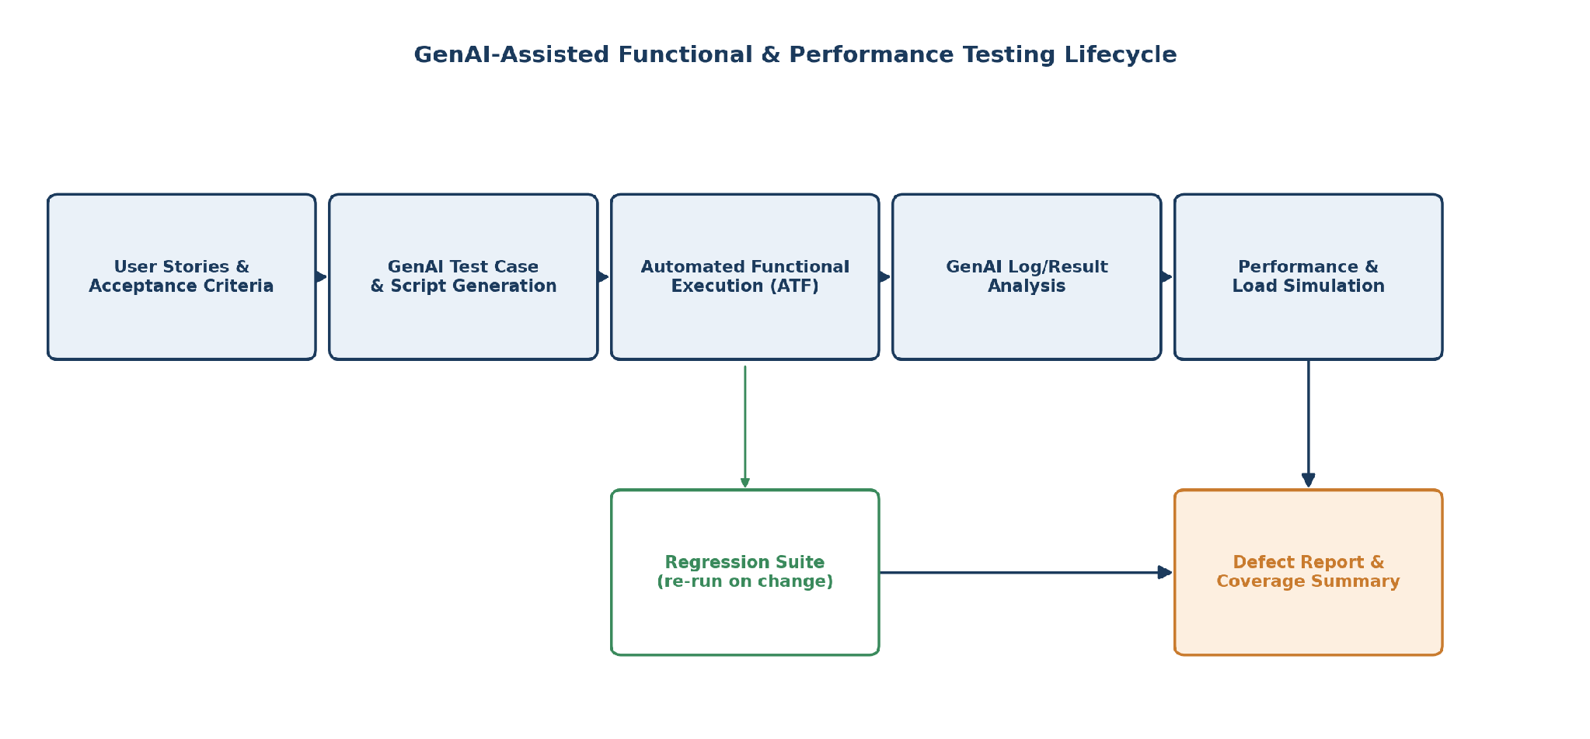
Figure 1: GenAI-assisted functional and performance testing lifecycle

4. Functional Testing with GenAI

4.1 Test Case Generation
GenAI models are prompted with the automated workflow's user stories and acceptance criteria (e.g., "as a network engineer, a low-risk request should auto-approve within 5 minutes") to generate structured functional test cases covering positive, negative, and boundary scenarios.

4.2 Automated Script Generation
Generated test cases are translated into ServiceNow ATF test steps, reducing the manual scripting effort typically required to build a full regression suite for a workflow of this complexity.

4.3 Edge Case Discovery
GenAI is used to propose edge cases that are easy to overlook manually, such as conflicting concurrent change windows, missing CI references, or malformed requester input, improving overall test coverage.

5. Sample Functional Test Cases
Test ID | Scenario | Expected Result
TC-01 | Submit a standard, low-risk network request | Auto-classified, auto-approved, and fulfilled without manual intervention
TC-02 | Submit a high-risk change (e.g., core router config) | Routed to manual approval; not auto-fulfilled
TC-03 | Submit a request with missing CI information | Workflow prompts requester or AI recommends the CI before proceeding
TC-04 | Two conflicting change requests on the same CI window | System flags scheduling conflict and blocks simultaneous execution
TC-05 | Requester checks status via self-service | Correct, real-time status returned from the workflow

6. Performance Testing with GenAI
Performance testing validates that the automated workflow remains responsive and reliable under realistic and peak load conditions, since network requests can spike during planned maintenance windows or organization-wide rollouts.

6.1 Load and Concurrency Simulation
- Simulate normal daily volume of network requests to validate baseline response time.
- Simulate peak load (e.g., quarter-end infrastructure refresh) to validate the workflow engine scales without SLA breaches.
- Simulate sustained load over an extended period to detect degradation or memory/queue build-up in Flow Designer executions.

6.2 GenAI-Assisted Log and Result Analysis
Rather than manually reviewing thousands of execution logs after a load test, GenAI is used to summarize failures, cluster similar errors, and highlight the most probable root cause, significantly reducing analysis time.

7. Performance Metrics Tracked
Metric | Target
Average request processing time | Under 2 minutes for standard requests
Workflow success rate under peak load | 99% or higher
Concurrent request handling | Supports at least 500 simultaneous submissions
System response time (self-service portal) | Under 3 seconds

8. Benefits of the GenAI-Assisted Approach
- Faster test case authoring compared to fully manual test design.
- Broader coverage through AI-suggested edge cases.
- Reduced regression testing effort as the workflow evolves.
- Quicker root-cause identification during performance testing.

9. Conclusion
Applying GenAI to functional and performance testing ensures the Automated Network Request Management workflow is validated thoroughly and efficiently before deployment. This reduces the risk of defects reaching production and gives confidence that the automated, audit-ready change process will perform reliably at scale.

